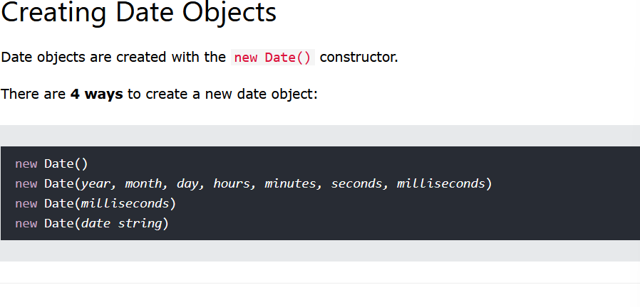

First one, creates date with the current date and time based on the user location

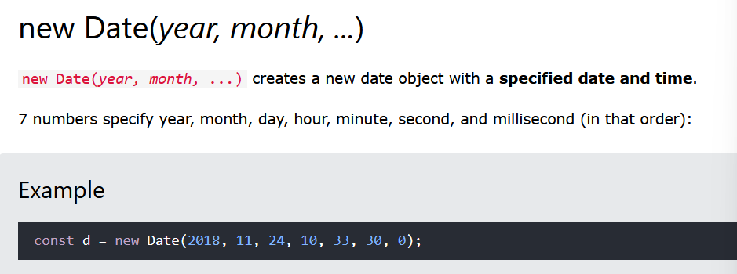

Here we may create date by any number

But the first two are minimum requirement

meaning at least the year and month are compulsory

Others are optional

Else if we provide only one argument then it will be counted as milliseconds

Also

In JavaScript

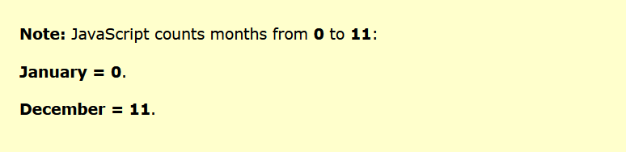

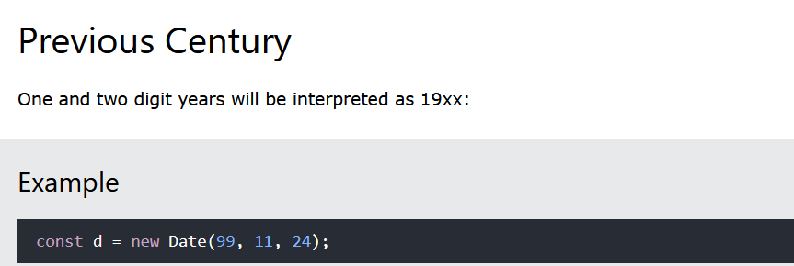

But

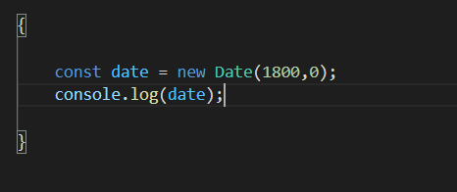

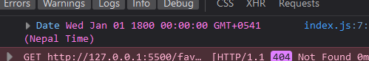

Here we did not provide two digits arguments for year, we provide whole 1800

**Providing singe arguments is treated as miliseconds**

